Exercise 1

Write a C++ Program that calculates the power of a base by a user defined function as follows:

* Take the power and the base from the user in the main function.
* Calcuate the power of the base in a user defined function “MY_POWER” by passing power and base from the main ( ) to the MY_POWER function.
* Calculated value must return from the function to the main and display there.
* Print the result as follows:

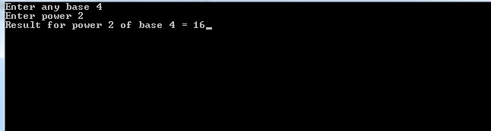

**SOURCECODE:**

#include<iostream>

using namespace std;

int power(int x, int y);

int main()

{

//Declaring Variables:

int a,b,c;

//Enter Base:

cout<<"Enter any base: ";

cin>>a;

//Enter Power:

cout<<"\nEnter power: ";

cin>>b;

//Calling Power function:

cout<<"\nResult for Power ["<<b<<"] of base ["<<a<<"] = ";

c=power(a,b);

cout<<c;

return 0;

}

//Calculate power Function:

int power(int x, int y)

{

int po,i,j=x;

//Apply for loop to calculate power:

for(i=1;i<y;i++)

{

//base multiply by itlself:

x*=j;

}

po=x;

return po;

}

**SCREENSHOT:**

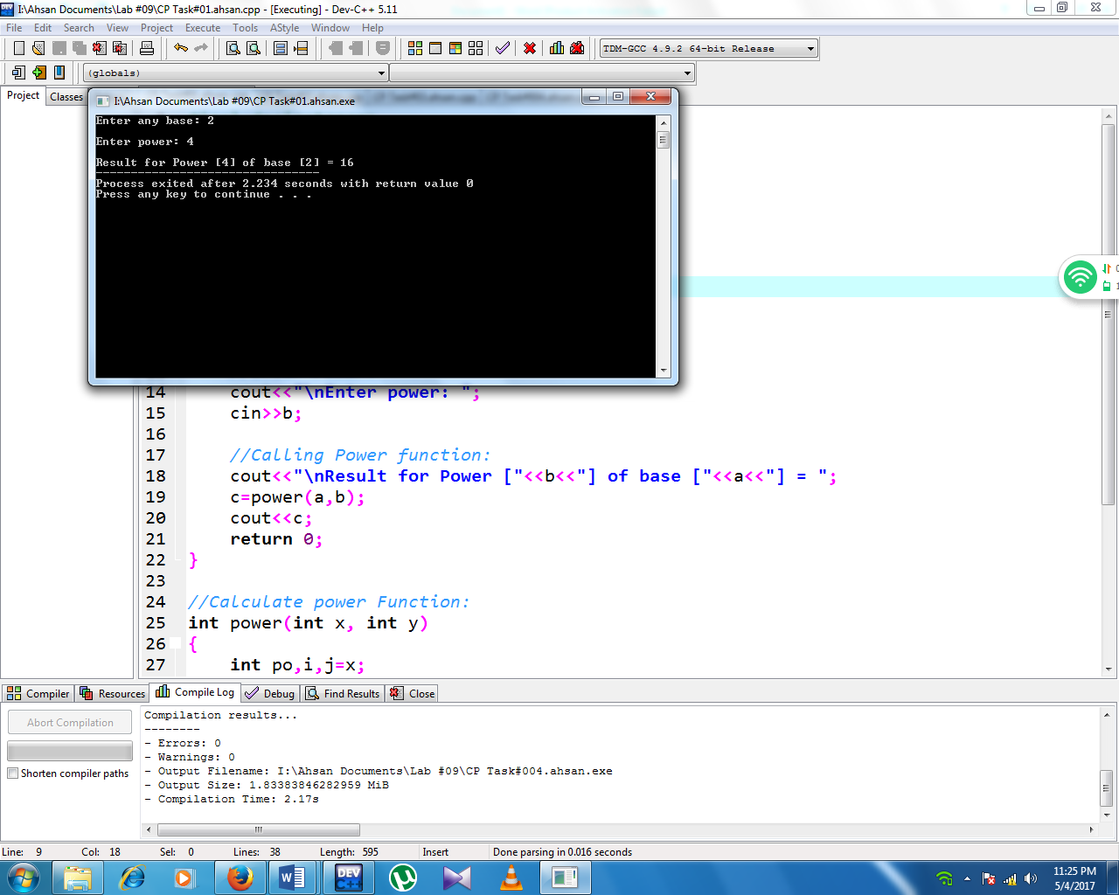

Exercise 2

Write a C++ Program that perform following task.

* Generate three random numbers ranged from 1 to 100.
* Calculate average of three numbers using a function avrg(int, int, int, int&).
* Calculate standard deviation and variance of three numbers.
* Print the results.

**SOURCECODE:**

#include<iostream>

#include<cmath>

#include<iomanip>

using namespace std;

void avrg(int,int,int,int&);

int main()

{

//Declaring Variables:

int a,b,c,av;

//Enter 3 Numbers:

cout<<"Enter any three num b/w 1-100:"<<endl;

cin>>a>>b>>c;

//if numbers are >100 & <1 then execute else block:

if(a>=1 && a<=100 && b>=1 && b<=100 && c>=1 && c<=100 )

{

//Calling average function:

avrg(a,b,c,av);

}

else

cout<<"Please Enter Correct Number:"<<endl;

}

//Average Calculating Function:

void avrg(int i,int j,int k,int&avg)

{

//Declaring Variables:

int x,d,e,f,g,h,l,m,n;

float o,Sdev;

//Calculate Average:

x=i+j+k;

avg=x/3;

cout<<"\n"<<setw(80)<<setfill('*')<<endl;

//print average value:

cout<<"\nThe Average Of Three Numbers is: "<<avg<<endl;

//Calculating Standard Daviation & Variance:

d=i-avg;

e=d*d;

f=j-avg;

g=f*f;

h=k-avg;

l=h*h;

m=e+g+l;

n=3-1;

o=m/n;

Sdev=sqrt(o);

//Print Variance Value:

cout<<"\nThe Variance Of These Numbers is: "<<o<<endl;

//Print Standard Deviation Value:

cout<<"\nThe Standard Deviation of these numbers is: "<<Sdev<<endl;

cout<<"\n**********************************************"<<endl;

}

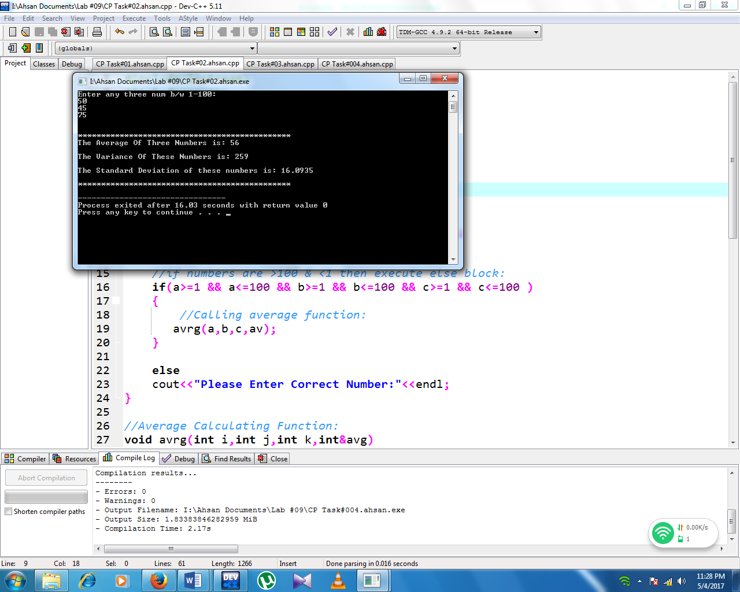**SCREENSHOT:**

Exercise 3

Write a C++ Program that contains four user defined function(s) *plus(int, int, int&), minus(int, int, int&), multiply(int, int, int&), divide(int, int, float&).*

* In main() function:
  + Get two numbers from user
  + Call four user defined fuctions
  + Variable to contain result should be decleared in main function and passed as reference to the user defined function.
  + Calculation must be done in the user defined function according to their names, e.g. plus() should perfom addition of the two variables. Variable to contain result shoud be updated in user defined function.
  + Print the result from main()

**SORCECODE:**

#include<iostream>

#include<iomanip>

using namespace std;

void add(int,int,int&);

void substract(int,int,int&);

void divide(int,int,float&);

void multiply(int,int,int&);

int main()

{

//Declaring Variables:

//integer Result & Float di are used as Pass by refrence variables:

int a,b,result=0;

float di=0;

//Enter Two number:

cout<<"Enter Any Two Numbers: "<<endl;

cin>>a>>b;

cout<<setw(73)<<setfill('=')<<endl;

//Call Add Function:

add(a,b,result);

cout<<result<<endl;

//Call Substract Function:

substract(a,b,result);

cout<<result<<endl;

//Call Divide Function:

divide(a,b,di);

cout<<di<<endl;

//Call Multiply Function:

multiply(a,b,result);

cout<<result<<"\n";

cout<<setw(45)<<setfill('=')<<endl<<"\n";

return 0;

}

//Addition Calculating Function:

void add(int i,int j,int&sum)

{

cout<<"\n\nThe Sum of two Numbers is: ";

//Calculate Sum:

sum=i+j;

}

//Substraction Calculating Function:

void substract(int i,int j,int&sub)

{

cout<<"\nThe Substraction of two Numbers is: ";

//Calculating Substraction:

sub=i-j;

}

//Division Calculating Function:

void divide(int i,int j,float&div)

{

cout<<"\nThe Division of two Numbers is: ";

//Calculating Division:

div=i/j;

}

//Multiplying Calculating Function:

void multiply(int i,int j,int&mul)

{

cout<<"\nThe Multiplication of two Numbers is: ";

//Calculating Multiplication:

mul=i*j;

}

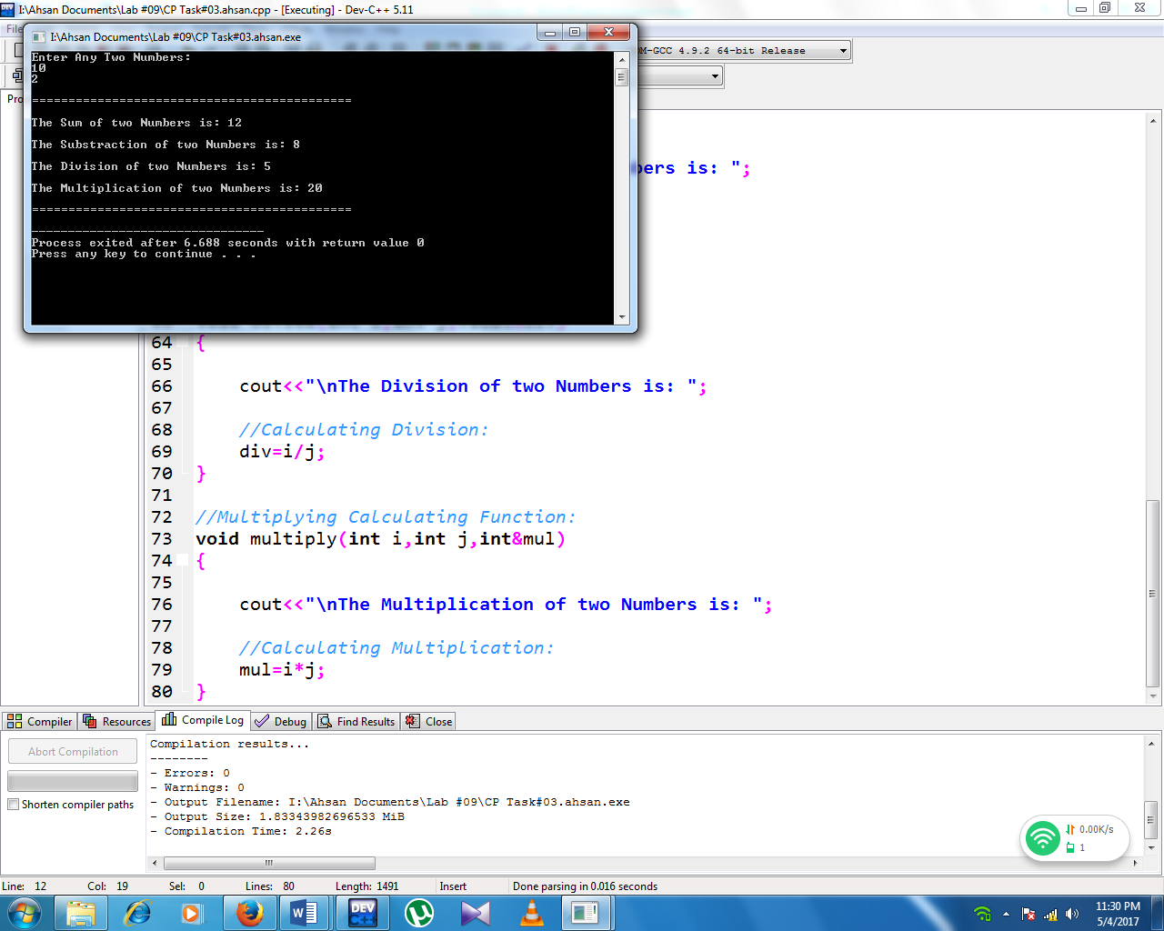**SCREENSHOT:**

Exercise 4

Write a C++ that calculate price of purchased fruits.

* A shopkeer supplies following fruits.
* Apple, Banana, Mango, Peach and Grapes
* Unit of each fruit per kg is:
  + Apple = 160
  + Banana = 120
  + Mango = 110
  + Peach = 100
  + Grapes = 130
* Ask user to enter purchased quantity of each fruits. Store values in variables.
* Write a function *Cal_Pric (int, int, int& total)* that calculate the price for each fruit.
  + For example *Cal_Price(160,2,total)* saves 320 in variable total.
* Print the results from main():

**#Sample Output**

**==================================**

**How many Apples did you buy : 2**

**How many Banana did you buy : 1**

**How many Mango did you buy : 3**

**How many Peach did you buy : 4**

**How many Grapes did you buy : 2**

**===================================**

**Price for Apple: 2 * 160 = 320**

**Price for Banana 1 * 120 = 120**

**Price for Mango: 3 * 110 = 330**

**Price for Peach: 4 * 100 = 400**

**Price for Grapes: 2 * 130 = 260**

**\*\*\*\*\*\*\*\*\*\*\*\*\*\*\*\*\*\*\*\*\*\*\*\*\*\*\*\*\*\*\*\*\*\*\*\*\*\*\***

**Total Price of your purchase is: 1430**

**\*\*\*\*\*\*\*\*\*\*\*\*\*\*\*\*\*\*\*\*\*\*\*\*\*\*\*\*\*\*\*\*\*\*\*\*\*\*\***

**SOURCECODE:**

#include<iostream>

#include<iomanip>

using namespace std;

void Cal_Price(int,int,int&);

int main()

{

//Declaring+Initializing Variables:

int a,b,c,d,e,app=160,man=110,ban=120,pea=100,gra=130,Tprice;

//Declaring Total Price & Total Purchase Variables:

int Tapp,Tban,Tman,Tpea,Tgra,Tpurchase;

cout<<setw(65)<<setfill('=')<<endl;

//Taking input of quantity of Apple,Banana,Peach,Mango,Grapes:

cout<<"\n\nHow many Apple Did you Buy: ";

cin>>a;

cout<<"How many Banana Did you Buy: ";

cin>>b;

cout<<"How many Mango Did you Buy: ";

cin>>c;

cout<<"How many Peach Did you Buy: ";

cin>>d;

cout<<"How many Grapes Did you Buy: ";

cin>>e;

cout<<setw(54)<<setfill('=')<<endl;

//Call Function Price:

Cal_Price(app,a,Tprice);

//Print Total Price Of Apple:

cout<<"\n\nPrice For Apple :"<<a<<" * "<<app<<" = ";

Tapp=Tprice;

cout<<Tapp<<endl;

//Call Function Price:

Cal_Price(ban,b,Tprice);

//Print Total Price Of Banana:

cout<<"Price For Banana :"<<b<<" * "<<ban<<" = ";

Tban=Tprice;

cout<<Tban<<endl;

//Call Function Price:

Cal_Price(man,c,Tprice);

//Print Total Price Of Mango:

cout<<"Price For Mango :"<<c<<" * "<<man<<" = ";

Tman=Tprice;

cout<<Tman<<endl;

//Call Function Price:

Cal_Price(pea,d,Tprice);

//Print Total Price Of Peach:

cout<<"Price For Peach :"<<d<<" * "<<pea<<" = ";

Tpea=Tprice;

cout<<Tpea<<endl;

//Call Function Price:

Cal_Price(gra,e,Tprice);

//Print Total Price Of Grapes:

cout<<"Price For Grapes :"<<e<<" * "<<gra<<" = ";

Tgra=Tprice;

cout<<Tgra<<endl;

//Calculate Total Purchase:

Tpurchase=Tapp+Tban+Tman+Tpea+Tgra;

cout<<"\n"<<setw(38)<<setfill('*')<<"\n"<<endl;

//Print Total Purchase:

cout<<"Total Price Of Your Purchase is: "<<Tpurchase<<endl;

cout<<"\n"<<setw(38)<<setfill('*')<<"\n"<<endl;

return 0;

}

void Cal_Price(int i,int j,int&total)

{

total=i*j;

}

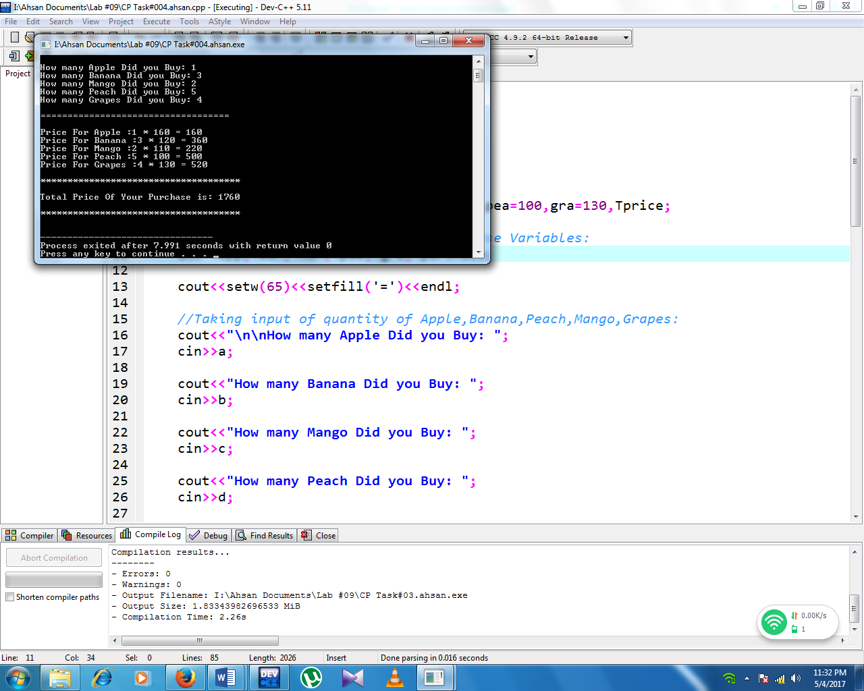**SCREENSHOT:**